ASSIGNMENT – 1

1. 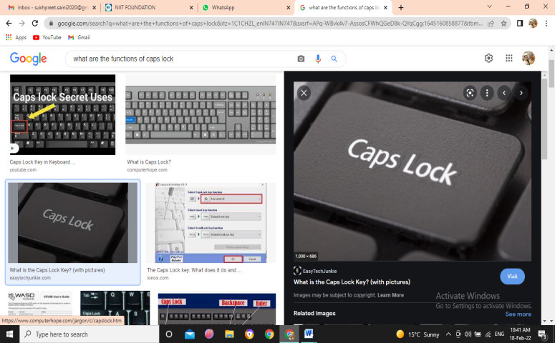Write down the functions of the following keys.
   1. Caps Lock- Caps Lock is a toggle key on a computer keyboard that causes all letters typed to be in uppercase until disabled.
   2. Num Lock- Number lock (num lock) is a key on a typical computer keyboard. It is a type of toggle key that, when switched on, enables the user to use the numeric keys on the keyboard, and when switched off, enables the use of other functionalities associated with the keys.
   3. Page Up- When this key is pressed, if the page currently being viewed has more than one page, the page moves ([scrolls](https://www.computerhope.com/jargon/s/scroll.htm)) up one page. For example, you can scroll down this [web page](https://www.computerhope.com/jargon/w/webpage.htm) and then press the Pg Up key to scroll back up.
   4. Print Screen- Print screen key places the screen capture in a large clipboard. It is necessary to paste it to word or an image processor like word or paint in order to view or save the screen capture
2. What is a File? Give three examples.

A file is an object on a computer that stores data, information, settings, or commands used with a computer program

* + EG (Joint Photographic Experts Group) ...
  + PNG (Portable Network Graphics) ...
  + GIF (Graphics Interchange Format) ...
  + PDF (Portable Document Format) ...
  + SVG (Scalable Vector Graphics) ...
  + MP4 (Moving Picture Experts Group)

1. 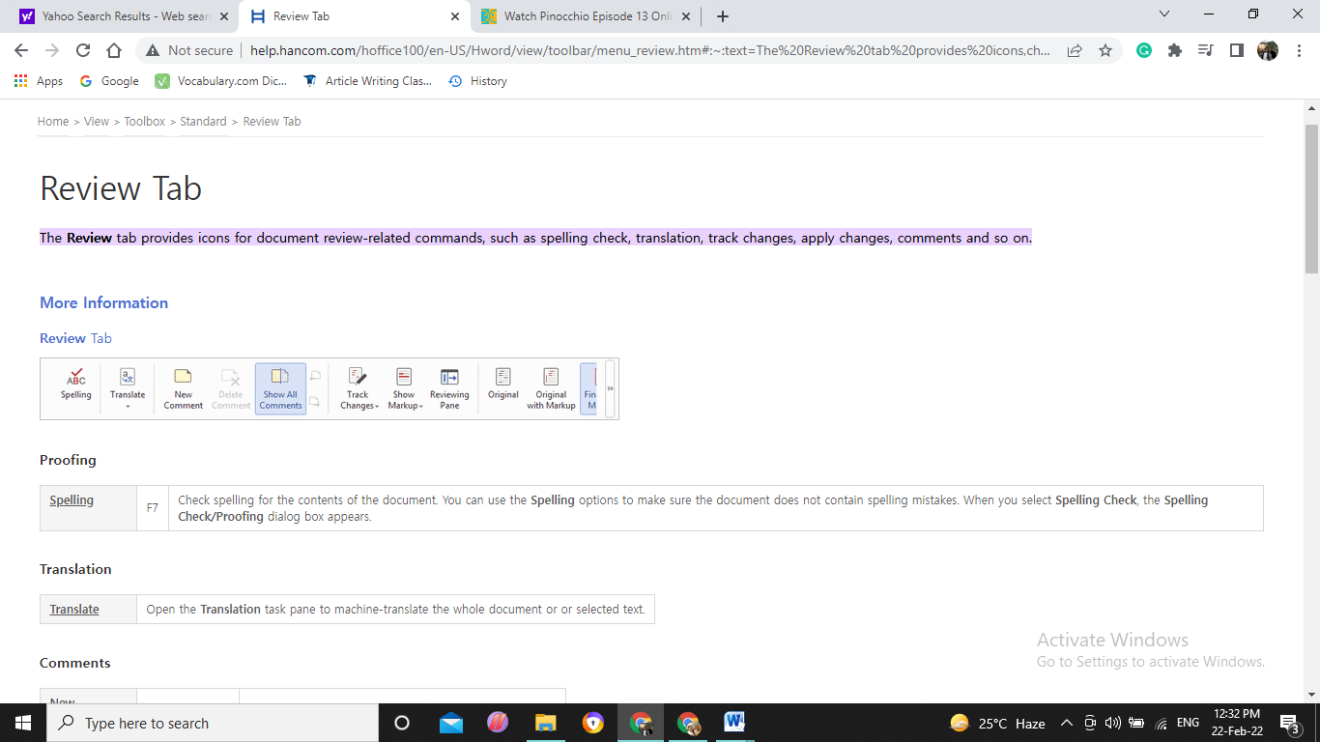What can you use the review tab for?

The **Review** tab provides icons for document review-related commands, such as spelling check, translation, track changes, apply changes, comments and so on.

1. How can you turn the “Track changes” on and off?

Turning on Track Changes gives you and your coworkers a way to make changes that are easy to spot. The changes are like suggestions that you can review, and then remove them or make them permanent.

